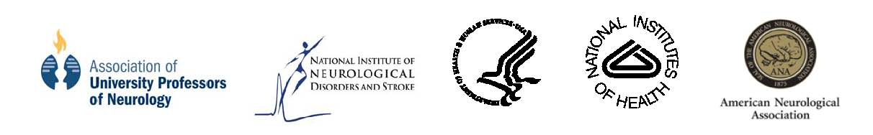
COMBINING CLINICAL AND RESEARCH CAREERS IN NEUROSCIENCE SYMPOSIUM

Washington, DC, May 29-30, 2009

Sponsored by: National Institute of Neurological Disorders and Stroke (NINDS), Association of University Professors of Neurology (AUPN), and the American Neurological Association (ANA).

Friday, May 29, 2009
East Registration Desk and Hampton Ballroom
6:30 - 7:30 p.m. REGISTRATION AND COCKTAIL RECEPTION

7:30 - 7:45 p.m. Welcome and Opening Remarks
Donna M. Ferriero, MD, University of California, San Francisco,
San Francisco, CA
Story C. Landis, PhD, NINDS, Bethesda, MD

7:45 - 8:45 p.m. DINNER

8:45 - 9:30 p.m. Combining Clinical and Research Careers: How I Am Doing It
Anna Penn, MD, PhD, Stanford University, Stanford, CA
Saturday, May 30, 2009
Hampton Foyer
8:30 - 9:15 a.m. REGISTRATION AND CONTINENTAL BREAKFAST

Hampton Ballroom
9:15 - 10:00 a.m. Overview
Bruce R. Ransom, MD, PhD, University of Washington, Seattle, WA

10:00 - 11:00 a.m. Residency Training and Beyond: Transitions and Career Vulnerability
John W. Griffin, MD, Johns Hopkins University, Baltimore, MD

11:00 - 12:30 p.m. Panel Discussion
Moderated by: Donna M. Ferriero, MD, University of California, San Francisco, San Francisco, CA

Governor’s Room
12:30 - 1:30 p.m. NETWORKING LUNCH

Hampton Ballroom
1:30 - 2:30 p.m. Research Training and Career Development
Dennis M.D. Landis, MD, Georgetown University, Washington, DC

2:30 - 3:30 p.m. Physician-Scientist. Career and Family: Can you have it all?
Karen C. Johnston, MD, MSc, University of Virginia, Charlottesville, VA

Hampton Foyer
3:30 - 3:45 p.m. BREAK

Breakout Rooms
3:45 - 5:00 p.m. Small Group Breakouts

Red Group: Embassy Room
Yellow Group: Chairman’s Board Room
Pink Group: Capitol Room
Green Group: Calvert Room
Blue Group: Senate Room

Governor’s Room
5:30 - 7:15 p.m. FINAL COCKTAIL RECEPTION – hors d’oeuvres will be served

Sunday, May 31, 2009 Departures

